**Finding the Focal Length of Curved Mirrors**

Aim: To draw ray diagrams for curved mirrors and use those diagrams to find the focal point and focal length of the mirror

Equipment:

* Hodson light box
* Power Pack
* Curved mirrors (one with high curvature, one with low curvature)
* Multiple slit slide (3 slits)
* Pencil and ruler

Method:

1. Connect the light box to the power pack.
2. Place the multiple slit slide in the light box.
3. Put the light box on the place indicated below, with the light rays shining towards the right side of the page.
4. Put the concave mirror with low curvature in the path of the light rays.
5. Mark the position of the mirror, by drawing along its inside edge.
6. Use a pencil to mark two dots for each incident and reflected ray on the sheet of paper.
7. Remove the mirror and trace these rays onto the page.
8. Mark the focal point of the mirror and measure the focal length.
9. Repeat steps 3 to 8 for the concave mirror with high curvature and the two convex mirrors.

Results:

**Concave mirror** – low curvature

Put light box here with light rays pointing 🡪

Focal length = ______________

**Concave mirror** – high curvature

Put light box here with light rays pointing 🡪

Focal length = ______________

**Convex mirror** – low curvature

Put light box here with light rays pointing 🡪

Focal length = ______________

**Convex mirror** – high curvature

Put light box here with light rays pointing 🡪

Focal length = ______________

Discussion:

1. Describe the differences between how the concave and convex mirrors reflect light.
2. Describe the effect of using a more curved mirror.

**Forming Images with Curved Mirrors**

Aim: To investigate the images formed with curved mirrors

Equipment:

* Concave mirror
* Convex mirror
* Candle
* White paper on a clipboard for a screen
* Blu-tac or plasticine

Part 1: Describing your reflection in different types of mirror

Method:

1. Hold the convex mirror at arm’s length and look at the image of your face.
2. Gradually move the mirror towards you until it almost touches your face.
3. Note any changes to the image of your face in the table below.
4. Repeat steps 1 to 3 for a concave mirror.

Results:

|  |  |  |
| --- | --- | --- |
|  | Convex Mirror | Concave Mirror |
| Image with mirror at arm’s length from face |  |  |
| Image with mirror close to face |  |  |

Part 2: Projecting an image with a concave mirror

Method:

1. 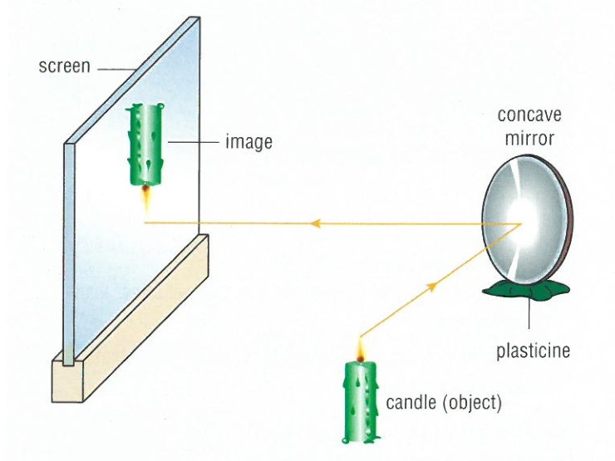Arrange the apparatus as shown in the picture
2. Move the screen until you obtain a clear image of the candle.
3. Describe the image that is formed.
4. Investigate the different images formed with the candle at different distances from the mirror. Is there a position where it is impossible to obtain an image on the screen?

Results:

Describe the image you produced.

What happened as you moved the candle closer to the mirror?

What happened as you moved the candle further away from the mirror?

Was there a place where you could not form an image?

What happened when the candle was very close to the mirror?

Discussion:

1. Explain what happens to the image as an object is brought closer to:
   1. A convex mirror
   2. A concave mirror
2. What type of images are possible in each type of mirror? (real or virtual, upright or inverted, magnified or diminished)
   1. Convex mirror:
   2. Concave mirror – far away:
   3. Concave mirror – close up: